Preparing ACWE Paper with MS Word

First Author a, Second Author b, Third Author c

aInstitutional Affiliation, Address without zip code, Country

bInstitutional Affiliation, Address without zip code, Country

cInstitutional Affiliation, Address without zip code, Country

ABSTRACT: The abstract (preferably 100-150 words) should comprise a brief and factual account of the contents and conclusions of the paper, as well as an indication of any new information presented, and its relevance. Complete sentences should be used, without unfamiliar abbreviations or jargon.

KEYWORDS: List up to 6 keywords.

# InTRODUCTION

We recommend that the paper length be at least five (5) pages - there is no maximum length since the conference proceedings will be circulated only in electronic form. This conference paper will not be peer reviewed. It is our intent that this paper serves as a starting point for a future journal manuscript if you so choose. The level of detail in this conference paper and your journal manuscript should be sufficiently different. The conference organizers will not be facilitating journal submissions (no special issues).

Please keep the file size of your conference paper under 50 MB by compressing images. This is necessary for ease of electronic distribution of the proceedings.

## General instructions

Authors of papers for these proceedings have to type them in a form suitable for direct reproduction by the publisher. In order to ensure uniform style throughout the volume, all papers have to be prepared strictly according to the instructions setout below. For the convenience of the authors, this template file for MS Word 2003 (and higher) is provided.

The directions in this template generally follow the Instructions for Authors given for the *Journal of Wind Engineering and Industrial Aerodynamics*.

## Type area

The text should be one column and should fit exactly into the type area of 16.51 × 22.86 cm (6.50” × 9.00”). For correct settings of margins in the Page Setup dialog box (File menu) see Table 1.

Table 1. Margin settings for Letter size paper

Setting Letter size paper

cm inches

Top 2.54 1.00

Bottom 2.54 1.00

Left 2.54 1.00

Right 2.54 1.00

First paragraph 0.0 0.00

Other paragraphs 0.50 0.20

## Style tags for text

The style tags (i.e., Normal text, Heading 1, Figure caption) for this paper have been defined within the template. Authors can access the list of style tags by clicking on the drop-down menu to the right of the AA on the toolbar (see Figure 1 for screen capture).

To apply a style tag to text, highlight the text to be formatted, then use the pointer to drop the menu and select the style tag to be applied. The text should automatically format to the specifications of the style tag.

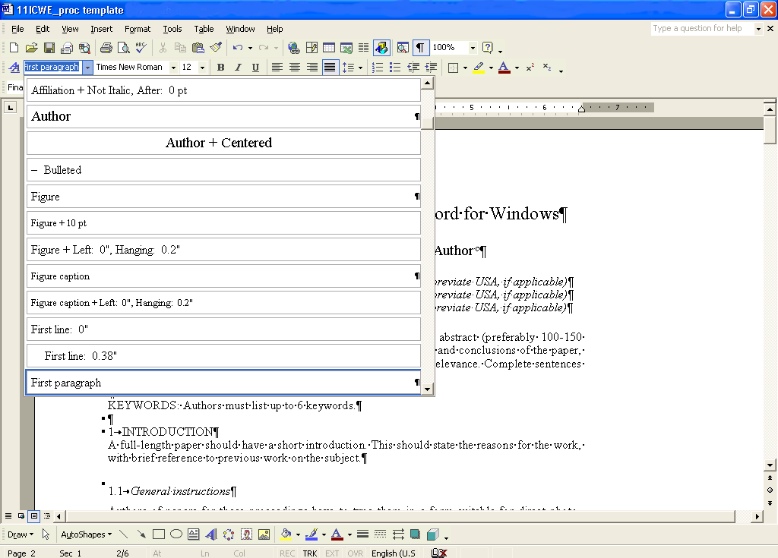

Figure . Screen capture of Style menu.

## Type font, size and spacing

All text should be typed in Times New Roman, 12 pt on 13 pt line spacing except for the paper title (18 pt on 20 pt), author(s) (14 pt on 16 pt), and the small text in tables, captions and references (10 pt on 11 pt). Use plain Times New Roman type except for parameters in mathematics (not for log, sin, cos, ln, max., d (in d*x*), etc.), Latin names of species and genera in botany and zoology and the titles of journals and books which should all be in italics**. Never use bold**, except to denote vectors in mathematics. Never underline any text. Use the small font (10 points on 11 points) for tables (Table tag), figure captions (Figure caption tag) and the references (Reference text tag).

First lines of paragraphs are indented 5 mm (0.2”) except for paragraphs after a heading or a blank line (First paragraph tag). Never add any space between lines or paragraphs. Never use letter spacing, and never use two consecutive spaces.

# Getting started

## Preparing the new file with the correct template

Copy the template file BBAA7_template.doc to your computer or disk. Start by renaming the document by clicking Save As in the menu Files. Put your sir name in the filename. (e.g., *Author*.doc). Now you can type your paper, or copy the old version of your paper onto this new formatted file.

## Copying old text onto new file

Open both your old file and the new file. Switch between these two with the Window menu. Select all text of the old file and paste to the bottom of the new file. Check the margin setting (Page Setup dialog box in File menu; see Table 1 for correct settings).

## Title, author and affiliation

Papers should be headed by a concise but informative title (preferably one line and only 7 words). This should be followed by the names of authors and by the name and address of the institution in which the work was performed. This information should be centered on the page. If the address of the author at the time when the paper will appear will be other than that where the work was carried out, this may be stated in a footnote.

Acknowledgements for financial support should *not* be made by a footnote to the title or name of the author, but should be included in Acknowledgements at the end of the paper.

## First line of text or heading

If your text starts with a heading, place the cursor on the I of INTRODUCTION and type the correct text for the heading. Now delete the word INTRODUCTION and start with the text after a return. This text should have the tag First paragraph.

If your text starts without a heading you should place the cursor on the I of INTRODUCTION, change the tag to First paragraph and type your text after deleting the word INTRODUCTION, but not the return at the end.

# Layout of text

## Headings

Type primary headings in capital letters Roman (Heading 1 tag) and secondary and tertiary headings in lower case italics (Headings 2 and 3 tags). Headings are set flush against the left margin. The tag will give two blank lines (26 pt) above and one (13 pt) beneath the primary headings, 1½ blank lines (20 pt) above and a ½ blank line (6 pt) beneath the secondary headings and one blank line (13 pt) above the tertiary headings. Headings are not indented and neither are the first lines of text following the heading indented. If a primary heading is directly followed by a secondary heading, only a ½ blank line should be set between the two headings. In the Word program, this has to be done manually as follows: Place the cursor on the primary heading, select Paragraph in the Format menu, and change the setting for spacing after, from 13 pt to 0 pt. In the same way the setting in the secondary heading for spacing before should be changed from 20 pt to 7 pt.

## Listing and numbering

When listing facts use either the style tag List signs or the style tag List numbers.

## Equations

Use the equation editor of the selected word processing program. Equations are not indented (Formula tag). Number equations consecutively and place the number with the tab key at the end of the line, between parentheses. Refer to equations by these numbers. See for example Equation 1 below:

 (1)

where *ca* = interface adhesion; δ = friction angle at interface; and *k*1 = shear stiffness number.

For simple equations in the text always use superscript and subscript (select Font in the Format menu). For example: From the above we note that sin θ = (*x* + *y*)*z*. Do not embed equations from the equation editor in the text on same line.

## Photographs and figures

Number figures consecutively in the order in which reference is made to them in the text, making no distinction between diagrams and photographs. Figures should fit within the type area width of 16.51 cm (6.50”).

Figures, photographs, etc. should be in gray scale only. Paste copies of the same size onto the typescript where you want them to appear in the text. Do not place them sideways on a page; however, if this cannot be avoided, no other text (except the figure caption which should also be placed sideways) should appear on that page. Figures, etc. should not be centered, but placed against the left margin. Leave about two lines of space between the actual text and figure (including caption). Never place any text next to a figure. Leave this space blank. The most convenient place for placing figures is at the top or bottom of the page. Avoid placing text between figures as readers might not notice the text. Line drawings (as well as photographic reproductions of these) should be in black (not gray) on white. The minimum size of lettering in figures should be 9 points. Lines should preferably be 0.2 mm (0.1”) thick. Keep figures as simple as possible. Avoid excessive notes and designations.



Figure 2. Caption of a typical figure.

Photographs should be black and white, with good contrast. The proceedings will be printed in black only. For this reason, avoid the use of color in figures and photographs.

### Figure captions

Always use the Figure caption style tag (10 points size on 11 points line space). Place the caption underneath the figure (see Section 4). Type as follows: ‘Figure 1. Caption.’ Leave about two lines of space between the figure caption and the text of the paper.

## Tables

Locate tables close to the first reference to them in the text. Careful thought should be given to the layout of Tables (and Figures) so that the significance of the results may be quickly grasped by the busy reader. Often a Table of results can be understood more readily if columns and lines are interchanged. It should also be remembered that the length of a printed page is greater than its width. Tables should be numbered with Arabic numerals (e.g., 1, 2, 3) and should have headings that make their general meaning understandable without reference to the text. The units in which results are expressed should be given at the top of each column (in parentheses) and not repeated on each line of the Table. Avoid abbreviations (except for units) in column headings. (For more instructions regarding units, see Section 5 Symbols and Units). Footnotes should be indicated by the use of lower-case letters (a, b, c, etc.), as superscripts without parentheses.

Use only horizontal rules: one above and one below the column headings and one at the foot of the Table (Table rule tag: Use the Shift-minus key to actually type the rule exactly where you want it). For simple Tables, use the tab key and not the Table option. Type all text in Tables in small type: 10 on 11 points (Table text tag). Align all headings to the left of their column and start these headings with an initial capital. Type the caption above the table to the same width as the table (Table caption tag). See for example Table 1.

## Conclusions

Conclusions should state concisely the most important propositions of the paper as well as the author’s views of the practical implications of the results.

# UNITS

Follow internationally accepted rules and conventions: use the international system of units (SI). If other quantities are mentioned, give their equivalent in SI.

# acknowledgements

This template is based on the template of CWE2006, which was held in Yokohama and was chaired by Professor Yukio Tamura.

# References

References should be numbered consecutively throughout the text and collected together in a reference list (headed REFERENCES) at the end of the paper. The references should be typed in small text (10 pt on 11 pt) and second and further lines should be indented 5.0 mm (0.2”) (Reference text tag).

Footnotes and legends should not include bibliographic material, and reference lists should not include material that could more appropriately appear as a footnote. Authors should ensure that every reference appearing in the text is in the list of references, and vice versa. Numerals for references are given in square brackets; numerals referring to equations are enclosed in parentheses.

The following system of giving references is required:

*Journals*

1 M.E. Greenway, An analytical approach to wind velocity gust factors, J. Ind. Aerodyn., 5 (1979) 61-91.

(Journal titles will be abbreviated in accordance with the *Engineering Index* system. Authors unfamiliar with this system may give full titles without abbreviation.)

*Monographs, Multi-author volumes, Proceedings*

2 W. Bach, Atmospheric Pollution, McGraw-Hill, New York, 1972, p. 94.

3 G.R. Lord and H.J. Leutheusser, Wind tunnel modeling of stack discharge, In M.A. Ward (Ed.), Man and his Environments, Pergamon, Oxford, 1970, Vol. 1, pp. 115-125.

4 M.E. Davies, V.G. Quincey and S.J. Tindall, The near-wake of a tall building block in uniform and turbulent flows, In J.E. Cermak (Ed.), Proc. 5th Int. Conf. on Wind Engineering, Fort Collins, CO, 1979, Pergamon, Oxford, 1980, Vol. 1, pp. 289-298.

References to a “private communication” are not to be given. A “personal communication” should be referred to only when permission has been obtained from the person who made the personal communication. A reference to “in press” implies that the paper has been accepted for publication.

In the text, an author’s name is given without initials, except where it is wished to avoid confusion with namesakes.

When reference is made to a publication written by three or more authors, it is preferable to give only the first author’s name in the text, followed by *et al*., or the name of one of the authors, followed by “and co-workers”. In the list of references, the names and initials of all authors must be given.

Consistency of style is very important. Note the spacing, punctuation and caps in all the examples below.

* *References in the text:* Figure 1, Figures 2-4, 6, 8a, b (not abbreviated)
* *References between parentheses:* (Fig. 1), (Figs 2-4, 6, 8a, b) (abbreviated)
* USA / UK / Netherlands / the Netherlands *instead of* U.S.A. / U.K. / The Netherlands
* Author & Author1 *instead of* Author and Author1